AOW 11 Period: Name:
- Summarize main and important points in margins, and underline key sentences.
- Include your own original reactions and questions in margins.
- Write a one-page reflection and attach it to the article.
Codes: MI=More Main Ideas need summarizing; OC=More Original Content needed
Report

Twelve facts about incarceration and prisoner reentry

Diane Whitmore Schanzenbach, Ryan Nunn, Lauren Bauer, Audrey Breitwieser, Megan Mumford, and Greg Nantz Friday, October 21, 2016, The Brookings Insitute

FACT 5 — Federal prisoners constitute a small share of the total prison population and are disproportionately likely to be drug offenders.
Federal sentencing reform (e.g., the Fair Sentencing Act of 2010 and the Retroactive Crack Cocaine Guideline Amendment of 2011) has tended to focus on reducing sentences for drug offenders. However, given that drug offenders constitute a relatively small fraction of the total prison population, such reforms are likely to have a limited impact on the overall level of incarceration. In 2014 there were more than 1.5 million individuals with a sentence of one year or more in either federal or state prisons. Of these, the vast majority—approximately 87 percent—were in state prisons.
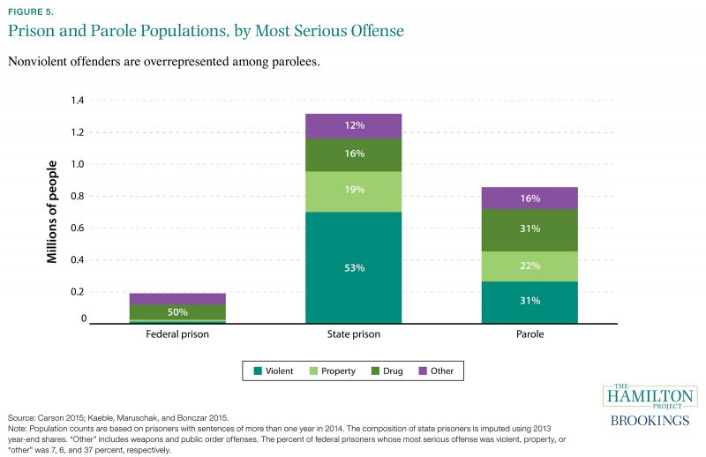
State and federal prisoners differ in the type of offense that leads to incarceration. More than half of federal prisoners are incarcerated for a drug offense, compared to just 16 percent of state prisoners. Conversely, more than half of state prisoners are incarcerated for a violent crime, compared to just 6 percent of federal prisoners (Carson 2015).
Nearly half of the combined state and federal prison population was sentenced for violent crimes. By comparison, of the parole population—approximately 860,000 individuals—slightly fewer than a third are violent offenders. This means that those who are leaving prison on parole tend to be nonviolent offenders, a fact that is likely relevant to discussions of reintegration.

FACT 6 — Black and white Americans sell and use drugs at similar rates, but black Americans are 2.7 times as likely to be arrested for drug-related offenses.
The disparate criminal justice experience of black Americans has played an important role in reform discussions. Differences in incarceration rates are stark: in 2007 a black man between the ages of 18 and 25 without a high school diploma was more than three times more likely to be incarcerated than a non-Hispanic white man of the same age and education level (Raphael 2011).
However, it is challenging to relate rates of criminal activity to differences in punishment. Data limitations make it helpful to focus on one type of criminal activity—drug-related crimes—and to allow for comparison by race between reported rates of selling and using illicit drugs to drug-related arrests, sentences, and incarceration.
Using the National Longitudinal Survey of Youth, we calculate rates of selling and using illicit drugs by race. Blacks and whites sell and use drugs at similar rates, as shown in figure 6a. However, the probability of experiencing criminal consequences is much higher, and those consequences are likely more severe, for blacks.
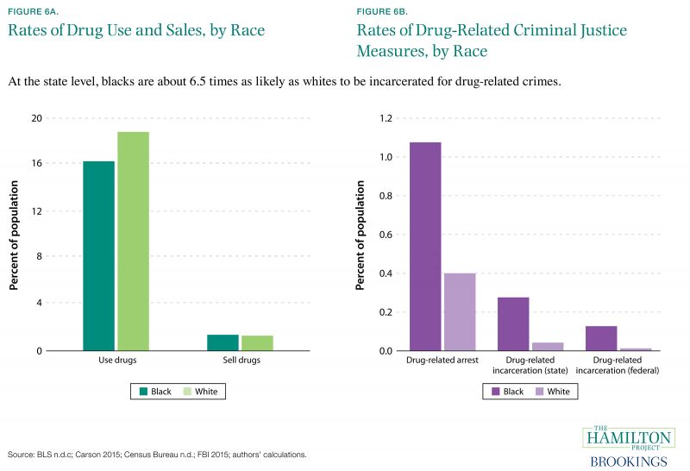
Blacks are 2.7 times as likely as whites to be arrested for a drug-related crime, and receive sentences that are almost 50 percent longer. Furthermore, blacks are 6.5 times as likely to be incarcerated for drug-related offenses at the state level. Drug-related crime is certainly a broad category that does not allow for distinctions to be made regarding the seriousness of the drug-related crime. Nevertheless, figure 6 suggests that criminal justice consequences by racial group are not proportional to rates of criminal activity

Possible Prompts:
- Some argue that people of color should be profiled and arrested more because they use more drugs than white people. What does this research suggest about that view?
- Though drug use is similar, black people are much more likely to be arrested for it, and they receive much longer sentences. What might account for these facts?
- Some argue that we need to increase our war on drugs in order to reduce crime, while others argue that the war on drugs has been unfair to poor people and people of color. Which side is right?

